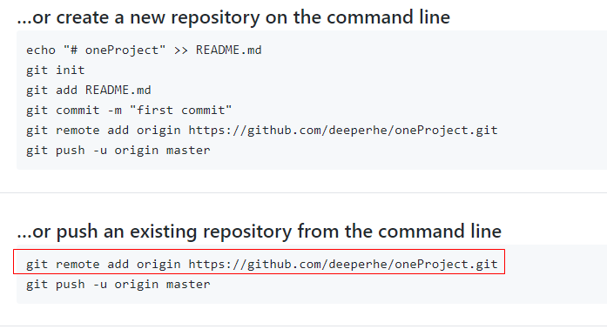

git remote add origin https://github.com/deeperhe/oneProject.git